ECA5802-IOE AND AI DRIVEN SYSTEMS

EXPERIMENT NO 2:
SIMUALTION AND PERFORMANCE EVALUATION OF PEOPLE-PROCESS-DATA-THINGS IOE FRAMEWORK USING EDGE AND FOG TO CLOUS PIPELINE

OBJECTIVES:
1. To simulate the People-Process-Data-Things (PPDT) framework for IoE applications using an Edge-Fog-Cloud pipeline.
2. To evaluate the system performance based on latency, data processing speed, and resource utilization.
3. To compare Edge, Fog, and Cloud computing approaches and identify their suitability for different IoE applications.

PROGRAM CODE:
import numpy as np
import matplotlib.pyplot as plt
# Simulation parameters
packet_size = 1500 * 8 # 1500 bytes converted to bits
# Data rate in Mbps
data_rate = np.linspace(0.5, 20, 100)
# Standard transmission delay formula
# Delay (ms) = Packet size (bits) / Data rate (bits/s) * 1000
transmission_delay = packet_size / (data_rate * 1e6) * 1000
# Illustrative fixed delay components in milliseconds
# These values are assumptions for simulation, not universal constants
data sources=20
# Edge
edge_propagation = 1* data sources
edge_processing = 2* data sources
edge_queueing = 0.5* data sources
# Fog
fog_propagation = 5* data sources
fog_processing = 4* data sources
fog_queueing = 1.5* data sources
# Cloud
cloud_propagation = 20* data sources
cloud_processing = 8* data sources
cloud_queueing = 3* data sources
# Total end-to-end delay
edge_delay = (
transmission_delay + edge_propagation
+ edge_processing + edge_queueing
)
print(edge_delay[50])
fog_delay = (
transmission_delay + fog_propagation
+ fog_processing + fog_queueing
)
print(fog_delay[50])
cloud_delay = (
transmission_delay + cloud_propagation
+ cloud_processing + cloud_queueing
)
print(cloud_delay[50])
# Plot results
plt.figure(figsize=(9, 5))
plt.plot(data_rate, edge_delay, label="Edge")
plt.plot(data_rate, fog_delay, label="Fog")
plt.plot(data_rate, cloud_delay, label="Cloud")
plt.xlabel("Data Rate (Mbps)")
plt.ylabel("End-to-End Time Delay (ms)")
plt.title("IoE Framework: Time Delay vs Data Rate")
plt.grid(True)
plt.legend()
plt.tight_layout()
plt.show()

OUTPUT GRAPH:
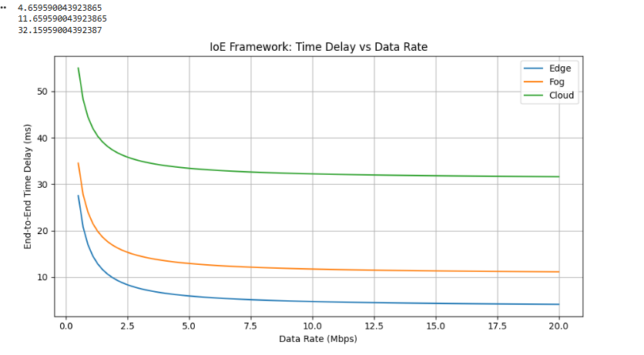
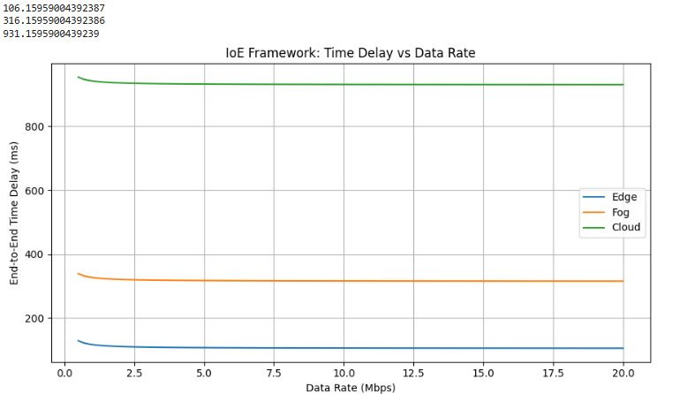

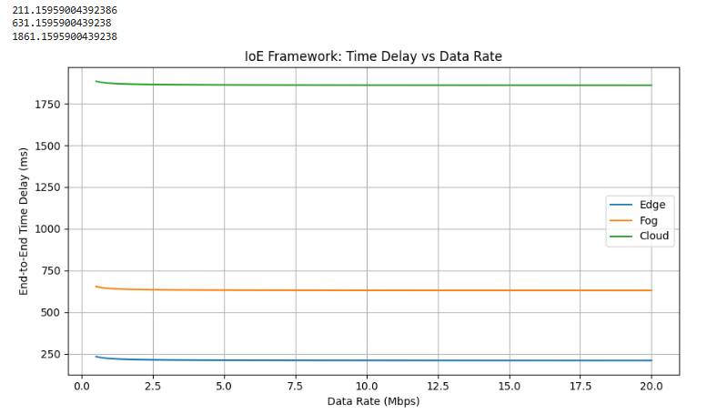

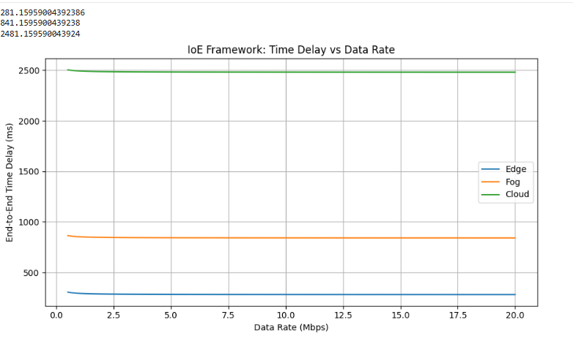

 |  | NUMBER OF DATA SOURCES
 | DELAY | 1 | 30 | 60 | 80
EDGE | PROCESSING DELAY | 2ms | 60ms | 120ms | 16ms
 | PROPAGATION DELAY | 1ms | 30ms | 60ms | 80ms
 | QUEUING DELAY | 0.5ms | 15ms | 30ms | 40ms
 | END TO END DELAY | 4.65ms | 106.15ms | 211.15ms | 281.15ms
FOG | PROCESSING DELAY | 4ms | 120ms | 240ms | 320ms
 | PROPAGATION DELAY | 5ms | 150ms | 300ms | 400ms
 | QUEUING DELAY | 1.5ms | 45ms | 90ms | 120ms
 | END TO END DELAY | 11.65ms | 316.15ms | 631.15ms | 841.15ms
CLOUD | PROCESSING DELAY | 8ms | 240ms | 480ms | 640ms
 | PROPAGATION DELAY | 20ms | 600ms | 1200ms | 1600ms
 | QUEUING DELAY | 3ms | 90ms | 5400ms | 240ms
 | END TO END DELAY | 32.15ms | 931.15ms | 1861.15ms | 2481ms
TABLE COLUMN:

RESULT:
The People-Process-Data-Things (PPDT) framework was simulated using the Edge-Fog-Cloud pipeline. The system performance was evaluated based on latency, data processing speed, and resource utilization. Edge and Fog computing reduced response time, while Cloud computing supported centralized data storage and large-scale data processing for IoE applications.

